Template for Evidence(s)
UI GreenMetric Questionnaire

University : ...
Country : ...
Web Address : …
SAMPLE
[2] Energy and Climate Change (EC)

[2.10] Greenhouse gas emission reduction program (EC.7)

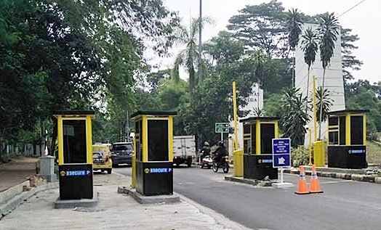 | 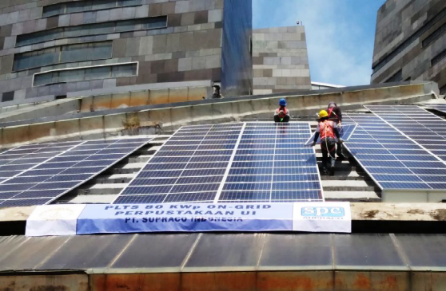
- Charge parking (Universitas Indonesia, Indonesia) | - renewable energy (Universitas Indonesia, Indonesia)

- Ride Share (Carleton University, Canada)

Description:
(Please describe the elements of green building implementation on your campus. The following is an example of the description. You can describe more related items if needed.)

The evidence provided may also include maps showing the location, area size, or distribution of facilities relevant to the indicators.

- Charging parking for private vehicle to reduce vehicle in campus
- Using renewable energy for electricity that reducing purchased electricity
- Ride share designed to encourage commuters to adopt healthy and sustainable transportation options. (Carpool)

Additional evidence link (i.e., for videos, more images, or other files that are not included in this file):
- https://carleton.ca/sustainability/campus/sustainable-transportation/carpool/

